

**VCU STREET PARKING ANALYSIS**

Class: OPER 490

Researcher: Jacob Isaacs

Technical Advisor: Paul Brooks

Analysis Completion Date: 4/15/15

Project Completion Date: 4/27/2015

**Table of Contents**

**Abstract…………………………………………………………………………....1**

**Similar Studies…………………………………………………………………….1**

**Methods…………………………………………………………………………....2**

**Choosing The Areas………………………………………………………………….....2**

**The Data Collection Evolution………………………………………………………....3**

**Calculating Inter-Arrival Rates……………………………………………………….4**

**Summary Statistics………………………………………………………...5**

**Simulation Creation…………………………………………................................5**

**Simulation Results Summary…………………………………………………….7**

**Final Analysis……………………………………………………………………...8**

**Conclusion…………………………………………………………………………9**

**Appendix Table of Contents…………………………………………………….10**

**Appendix……………………………………………………………………...11-19**

**Citations………………………………………………………………………20-21**

**Abstract:**

The goal of this project was to effectively analyze and simulate street parking around VCU campus. The study will discuss information based on other parking research studies, and why parking is an issue that must be taken into consideration. The data that was collected for this project was done by hand over the course of five days in six different areas. This report will go in detail of how the data was collected and methods learned about how to collect the data. The report will discuss methods of acquiring summary statistics from the collected data, and then discuss the simulation and its results. The results have a large amount of information in regards to all six areas. The information is organized by numerical, probability and graphical methods. Some of this information includes parking probability, arrival rates of the cars, how many cars park within an inter-arrival rate.

**Similar Research Studies:**

There are several studies that explore different issues involving parking. There are 11 citations listed at the end of this report that contain similar parking studies. The projects that are most similar to this one use parking simulation models to determine a good size for a parking area (in places such as hospitals and airport terminals). Some projects also determine the best type of parking regulation to enforce in a particular area. There is one paper that was particularly interesting that discussed the reason why parking spaces are so important by a professor of urban planning named Donald Shoup. He explained that it was difficult to conduct a study that determines how much traffic is created by people cruising for a parking spot, however it is likely the reason for a large amount of traffic congestion. One study that was inspired by Donald Shoup called No Vacancy found that there was a significant amount of traffic created by people who are cruising for a parking spot. They explained that 45% of total traffic was cruising for parking in their area. The No Vacancy study inspired the simulation in this project’s inclusion for a parking probability that is calculated by the number of parks that occurred and the number of cars that have gone through the area. A better parking probability can be created if a survey is conducted to determine if the entering car planned to park in the area.

**Methods:**

**Choosing the Areas:**

When choosing the areas for study determining if the area contained parking restrictions was taken into consideration. A parking restriction could either be a meter requiring a payment for parking, a time limit, or signs that do not allow parking for reasons such as street cleaning or events. Logically it is easier to find a parking spot in a regulated area because there are fewer cars. The benefit of having regulated areas is that they are more ideal for pick up, drop off or going to get something quick. However, regulated areas pose a larger risk of receiving a parking ticket. Students can purchase a parking permit to park on campus. There are several reasons of why a student would want to purchase a permit a few of these reasons are that it provides protection for their car, it ensures a spot close to campus and it’s cheaper than paying meter prices. However, most commuter students that wish to leave their cars over the course of the day without a permit will scout out a spot that have no regulations. These parking areas that the commuter students use are limited. Being a former commuter student, I found myself parking somewhat far away from campus. Four no regulation areas for the study were places that I would leave my car during my class hours. There are two additional areas that were studied closer to campus that are regulated. There is a table that contains two restrictions and the area number in Appendix A-1. In addition to the table there are maps that show the study area locations in Appendix A-2.

**The Data Collection Evolution:**

As the project progressed there were different methods and items added to the way data was collected. The evolution of this data collection happened due to an inability to effectively record how fast cars were coming into different areas. The evolution of the way data was collected is displayed in Appendix A-3. There is a finite amount of data a person can write in an amount of time. A quick time test of the human ability to write entries down was produced. The time test resulted in approximately 4-6 written entries every 10 seconds.

The first stage evolution of the data collection started with the basic idea of collecting information about the area. Data was collected while a stopwatch ran continuously for an extended period of time. The kinds of information that were collected is as follows, total number of available spots, number of spots taken at time 0, the times the data was collected, the time when a car arrived, parked, parked car left and the time a car left the area.

The second and third stages of evolution modified the basic structure of the first stage. The second stage of evolution included a tally to count the number of cars. The tally allowed for the determination of the amount of missing arrival times. Some of the statistical summaries discussed later have entries in the tally area. Even though the tallies determined the number of arrival times missing, it did not create times for the missing cars.

The third stage of data collection was created to accommodate arrival rates for the missing cars in the second stage. The third stage of data collection added a section to enable writing down the number of cars that were coming in at different time intervals.

**Calculating inter-arrival rates:**

When calculating the inter-arrival times of the arrival, park, park leave and leaving rates of vehicles, the third stage evolution of data collection posed the most difficulty. In order to calculate the third stage inter-arrival times a macro code in VBA was created to quicken the task (macro-code listed in Appendix B-1).

The macro code takes the next time value and subtracts it from the current one. A simple inter-arrival calculation is Inter-arrival = Next Time – Current Time. However, there are multiple cars coming in between arrivals for some of the areas, so an additional calculation must be created. The calculation takes the original inter-arrival rate and divides it by the number of cars that came in to produce an average sub-interval time. This sub-interval time then can be added in iteration by the number of cars to the start time. The mathematical formulation of the code is listed in Appendix B-2.

@Risk software was used to fit distributions to the inter-arrival times once the inter-arrival rates were calculated. @Risk software creates several different kinds of distributions with input data then rates all of the distributions using five different rating scales. The distributions and distribution rating scales @Risk produces can be seen in Appendix B-3. For this project the AIC (Akaike information criterion) rating scale was used. @Risk software was used to alleviate the challenge of completing a task that could have been done by hand. If a hand calculation is to be done of one of the distributions, it can be time consuming, this can be seen by a written out formula of the normal distribution with some sub calculation displayed in Appendix B-4. In addition the AIC rating scale calculation can be seen in Appendix B-5.

One thing to note when using @Risk Software is that Excel’s formatting of time does not translate well. When the inter-arrival rates are in the format of hh:mm:ss and the @Risk software package is used, the format turns into values not easily recognized as units of time. In order to alleviate this problematic instance the hh:mm:ss format was changed into seconds. hh:mm:ss format can be changed into seconds by converting it into a value then multiplying the value by 60 and 24.

**Summary Statistics:**

Once the inter-arrival rates were computed a summary statistic review sheet was created. This sheet contained all of the information that was needed to create the simulation. The information included inter-arrival rate distributions from the car arrive rate, car park, parked car leave, and car leaving rates. Some additional items were produced when forming the summary. The parking probability was deciphered from counting the number of written inter-arrival rates underneath the car arrive and park tabs. A total run length time was entered by choosing the last time an observation was recorded. The initial state conditions were added in to account for the cars in the parking area at time 0. Lastly a simple error calculation was posted in the upper right hand corner if a tally was recorded. The summary statistic can be seen in appendix C.

**Simulation Creation:**

The simulation was created using Arena simulation software. This software uses queueing theory to produce realistic simulations. While the simulation model was being created certain realizations occurred, and they will be discussed in this section. A basic model was created and additional pieces to the basic model were added later on to gather more information.

During the development of the simulation logic, there was a realization that there did not have to be both a parking arrive rate and a cars arrive rate. Because of how Arena Simulation software works, “Cars Arrive Area 1” block already creates entities that arrive in the parking area. In order to account for all of the cars going through the area only the parked car leaving process was utilized in the simulation. An additional simulation can be created that utilizes the park inter-arrival rate collected in the statistical summary, but for simplicity this project will focus only on one simulation.

This simulation diagram was created from the information in the summary statistics (see Appendix D-1). The simulation logic will now be described from the creation block to the dispose block. Cars arrive at a rate into the area with the “Cars Arrive Area 1” block then go through a decision block labeled “park prob” (prob is short for probability). The “park prob” decision block is based on a 2 way probability that was calculated earlier as the (total number of cars that parked) / (the total number of cars that have passed through the area). The second decision block called “Space Available Area 1” checks to see if the parking queue or area has met capacity. The “Space Available Area 1” block checks the park area capacity by using a 2 way condition statement linked to the assignment block labeled “Assign Number of Cars in Park Area 1”. The condition statement is the number in the parking area < capacity of the parking area. This condition prevents the simulation from adding more cars than there are spots in the parking area. There is a creation block labeled “cars currently in area 1” that lies after the “space available area 1” block that delivers the amount of cars that were already parked in the area at time 0. The “car parks Area 1” block is a seize delay release process block that uses one resource labeled park place. Parked cars leave one after the other based on the inter-arrival rate calculated earlier as park leave. The process block labeled car leaves is just a delay block that accounts for the amount of time it takes a car to leave the area. The dispose blocks are not particularly important for discussing final analysis, but are more important in the scheme of making sure the simulation runs properly.

When collecting results from the simulation logic above, there were additional record blocks that were created to the model. The record blocks add additional averages in the software’s result analysis. The additional record blocks that were created produced the following statistics: the number of cars wishing to park, number not parking, and number of cars leaving due to no spot availability. The basic logic diagram with added record blocks is displayed in Appendix D-2.

A single frame of the Area 1 animation is displayed in Appendix D-3. This was created to demonstrate a visual representation of the parking area. Animations for the other areas were not produced as they are not important in determining the mathematical results of this report.

After a simulation for an area was created a process analysis was done to create a graph that showed the fluctuation in the average number of cars in the parking area. This graph is listed below the numerical results in the simulation summary (see Appendix E).

**Simulation Results Summary:**

All of the areas were simulated; the summary of results is seen in Appendix E. The pieces of information that were collected from the simulation were number of replications, replication length, cars wishing to park, no space available car leaves, car drives through area without parking, the time a car is in the parking area, the average time a car is in the area, and a graph representing 50 replications of the average number of cars parked.

The replication length for each simulation is the same as the amount of time that data was recorded. This ensures that the simulation is accurate to the data provided. If the replication length was longer than the time the data was collected it would cause the parking queues to explode or deteriorate. This is because the collected data in areas resulted in the car parking rates being either faster or slower than the parked car leaving rates.

**Final Analysis:**

A final analysis is displayed in appendix F-1 that includes averages of the six different areas to answer the question of just how likely it is to find a parking spot around campus. There are a total of 21305 seconds of data collection that occurred which equates to 5 hours 5 minutes and 5 seconds. The average number of cars wishing to park based on 6 areas 15.03 cars with in a replication length of 3550.833 seconds or 15.03 cars park approximately every 59 minutes and 10 seconds. The parking area hits capacity while a car tries to park approximately once every 59 minutes. The average time a car spends in an area is 405.1292 seconds which equates to 6 minutes and 45 seconds. The average time a car spends parked across all 6 areas is 1627.9567 seconds or 27 minutes and 8 seconds.

An additional cross sectional analysis may be of interest. A combination of areas based on parking regulations is listed in Appendix F-2. Regulated areas have a significantly higher parking rate than unregulated areas. Also there is more time spent in the parking queue for these regulated areas. An additional reason why there is more parking occurring in the regulated areas is possibly due to these areas being a point of interest for a large amount of people. The occurrence of a car attempting to park with the parking area at capacity is higher for regulated areas than it is for the unregulated areas. The average time a car spends in a regulated area is impressively higher than in unregulated areas. The time spent in a regulated system is on average clocked at 775 seconds where as the time spent in an unregulated area is 220 seconds. This result may have occurred because there are more cars just passing by the unregulated areas than the regulated areas. Another additional graph is listed above displaying the average number of cars using the area for parking.

**Conclusion:**

Street parking around VCU for commuters has regulated areas more beneficial for picking things up and dropping things off and also un-regulated areas more beneficial for leaving your car for an entire day. The final analysis gives a good numerical review of how fast cars are parking, leaving their cars, and leaving the areas, however, like any study improvements can be made. Some of these improvements could be to minimize the human error during the study by having several people analyze small portions of the street parking area for a longer amounts of time, or to use computer sensors to analyze each spot. The simulation in this study does a good job of getting a general idea of what cars are doing around the street parking areas; however, there are other methods of simulation that could provide a more complex simulation. The simulation in this study looked at a parking area as a whole rather than individual spots like the one done by Dunwoody (Dunwoody, 2014). Dunwoody uses station blocks in the simulation for each parking space. In conclusion, this report did its job of presenting ways to collect data, creating summary statistics and simulating the summary statistics to provide answers to questions about the efficiency of VCU street parking.

**APPENDIX**

**Appendix Table of Contents:**

**Appendix A: Contains Data Collection Tables**

**1. Restrictions on areas table**

**2. Map of Areas**

**3. Evolution of Data Collection**

**Appendix B:**

**1. Excel Macro-Code**

**2. Mathematical formulation of sub inter-arrival rates**

**3. @Risk distributions and tests**

**4. Normal curve distribution equations**

**5. Akaike Information Criterion**

**Appendix C: Summary Statistics**

**Appendix D: Simulation Models**

**1. Basic Model**

**2. Model with record blocks**

**3. 1-frame Animation figure**

**Appendix E: Simulation Results Summary**

**Appendix F: Final Analysis Results**

**1. Total Result Statistics: A combination of all Areas**

**2. Comparison Summaries of Regulated vs Un-regulated areas**

**APPENDIX A:**

****1)2)

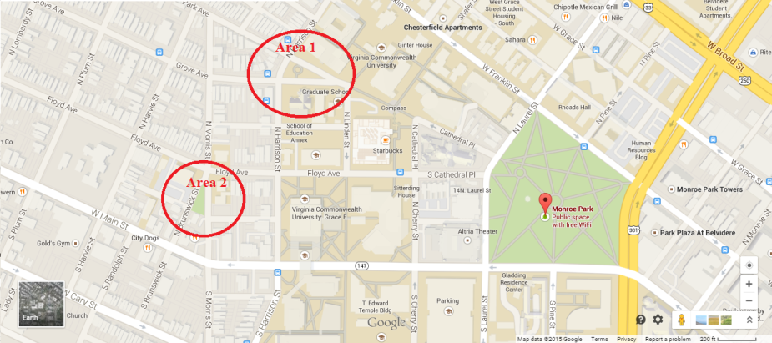

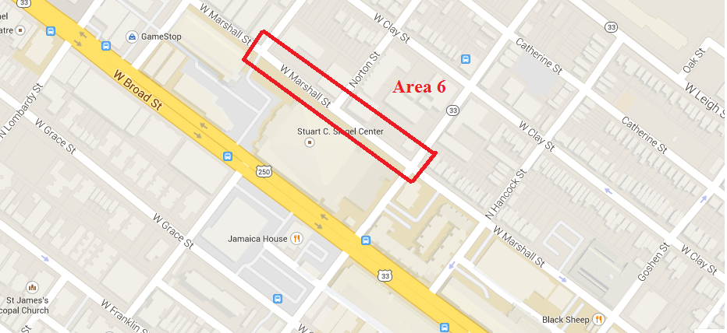

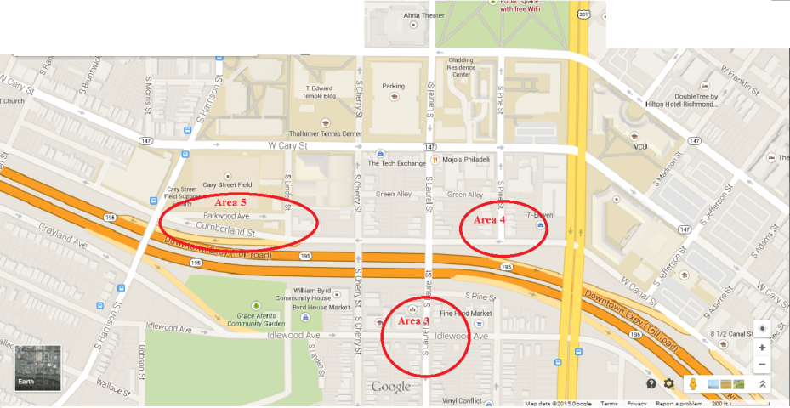



Evolution 1



Evolution 2



Evolution 3

**APPENDIX B:**

2

1

Option Explicit

Sub times()

'

' times Macro

'

' Keyboard Shortcut: Ctrl+t

'

ActiveCell.FormulaR1C1 = "=RC[-3]-R[-1]C[-3]"

ActiveCell.Offset(1, 0).Range("A1").Select

ActiveCell.FormulaR1C1 = "=R[-1]C/R[-1]C[-2]"

ActiveCell.Offset(1, 0).Range("A1").Select

ActiveCell.FormulaR1C1 = "=R[-3]C[-3]+R[-1]C"

ActiveCell.Offset(1, 0).Range("A1").Select

ActiveCell.FormulaR1C1 = "=R[-1]C+R[-2]C"

ActiveCell.Offset(1, 0).Range("A1").Select

ActiveCell.FormulaR1C1 = "=R[-1]C+R[-3]C"

ActiveCell.Offset(1, 0).Range("A1").Select

ActiveCell.FormulaR1C1 = "=R[-1]C+R[-4]C"

ActiveCell.Offset(1, 0).Range("A1").Select

ActiveCell.FormulaR1C1 = "=R[-1]C+R[-5]C"

ActiveCell.Offset(1, 0).Range("A1").Select

ActiveCell.FormulaR1C1 = "=R[-1]C+R[-6]C"

ActiveCell.Offset(1, 0).Range("A1").Select

ActiveCell.FormulaR1C1 = "=R[-1]C+R[-7]C"

ActiveCell.Offset(1, 0).Range("A1").Select

End Sub



3

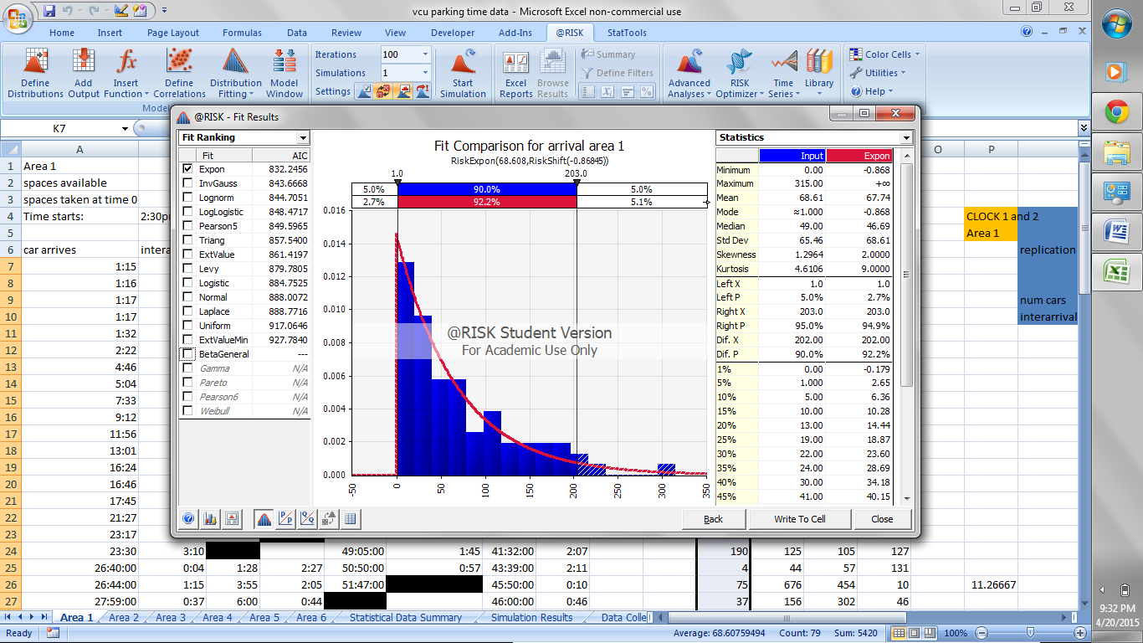

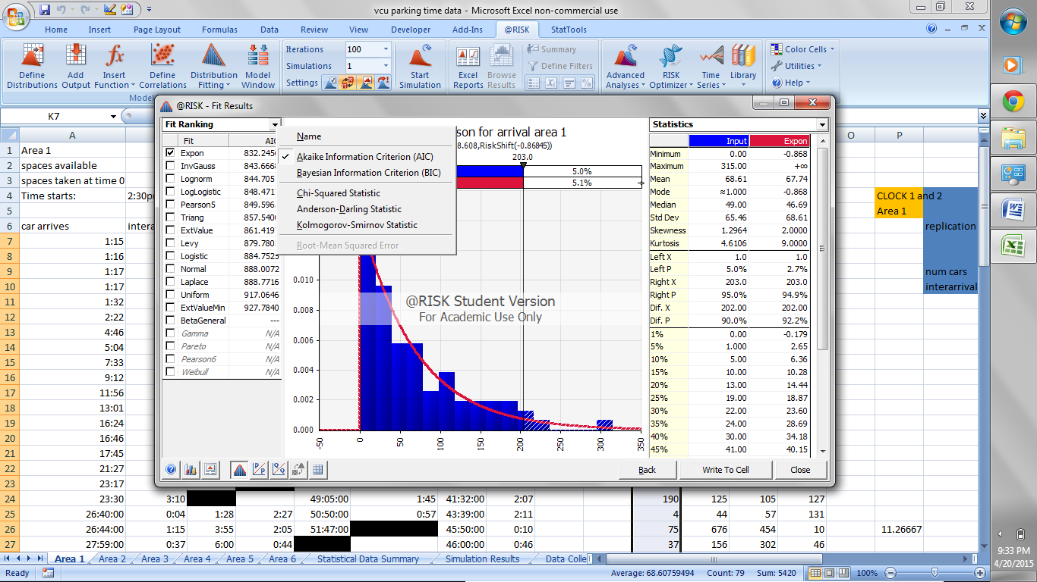



5

Normal curve equation: 

Sub calculations:  and 

4

**APPENDIX C:**



**APPENDIX D:**

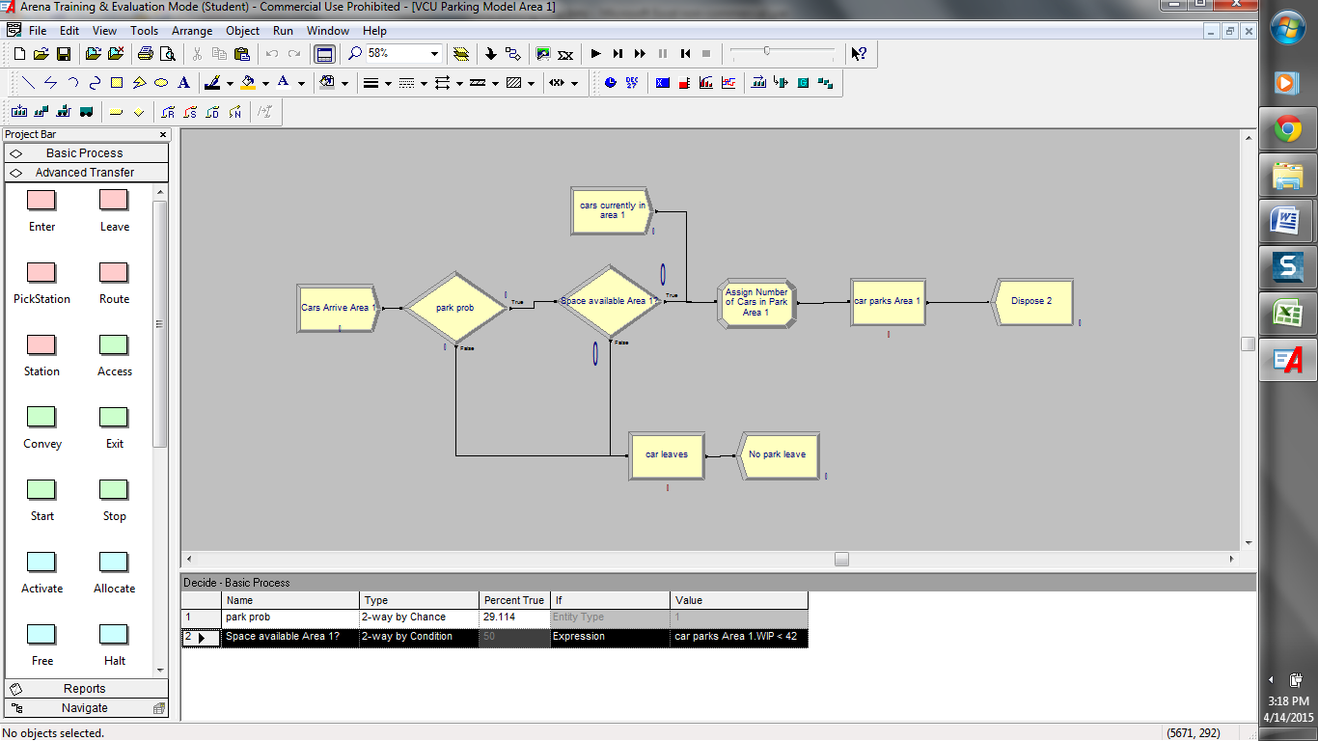

1

2

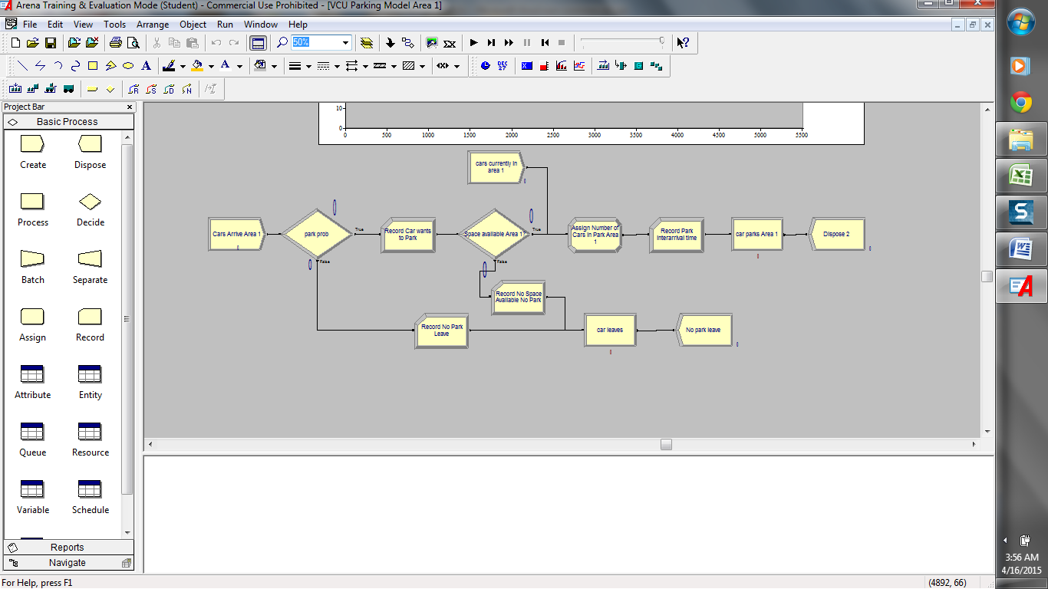

3

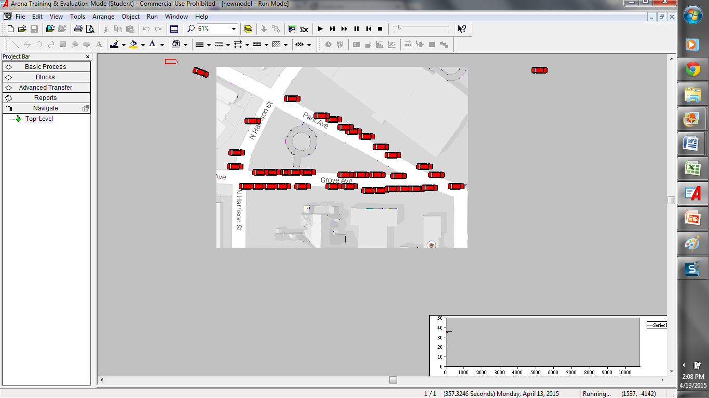

**APPENDIX E:**













**APPENDIX F:**

1



2





3

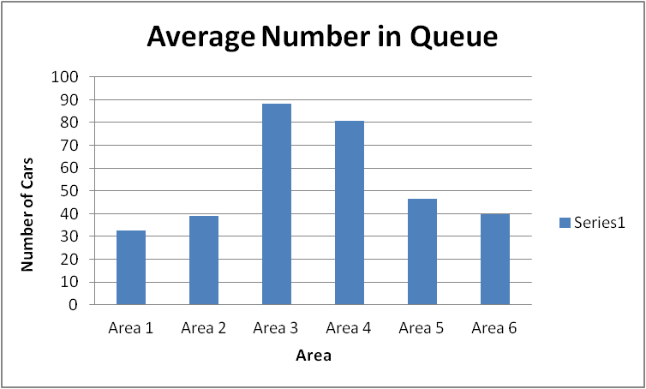

**Citations**

1. Kuo-Yang, Chang. "A simulation model for analyzing airport terminal roadway traffic and curbside parking." (2001): n.pag. *ProQuest Dissertations & Theses Global*. Web. 04/01/2015. <http://search.proquest.com/docview/304698481/abstract/732B15EDED974444PQ/1?accountid=14780>.

2. Shoup, Donald. "Cruising For Parking." Web. <http://shoup.bol.ucla.edu/CruisingForParkingAccess.pdf>.

3. Massoud, Javid. "Probabilistic model for determining optimum size of parking facilities at airports." (1999): n.pag. *ProQuest Dissertations & Theses Global*. Web. 1 Apr 2015. <http://search.proquest.com/docview/304531024/abstract/9DF9286CFA1A4E43PQ/1?accountid=14780>.

4. Pavo, Marvin. "Parking Design Considerations." *scribd*. N.p., 11 Mar 2015. Web. 1 Apr 2015. <http://www.scribd.com/doc/258345545/Parking-Design-Considerations>.

5. Larson, Richard, and Katsunobu Sasanuma. "Congestion Pricing: A Parking Queue Model."*Journal of Industrial Systems Engineering*. N.p., 00 Spring 2010. Web. 1 Apr 2015. <http://www.jise.ir/article_4018_623.html>.

6. "No Vacancy Park Slope’s Parking Problem And How to Fix It."*Transportation Alternatives*. Transalt, 00 Feb 2007. Web. 1 Apr 2015. <http://www.transalt.org/sites/default/files/news/reports/novacancy.pdf>.

7. Kelton, David, Randall Sadowski, and Nancy Zupick. *Simulation with Arena*. 6th ed. New York: McGraw-Hill Education, 2015. Print.

8. Seba, Petr. "Markov chain of distances between parked cars.." (2008): n.pag. *MathSciNet*. Web. 1 Apr 2015. <http://iopscience.iop.org.proxy.library.vcu.edu/1751-8121/41/12/122003/pdf/1751-8121_41_12_122003.pdf>.

9. Weiner, Howard J. . "Central Limit Theorem for Parking Models on the Line and Plane."*Sankhyā: The Indian Journal of Statistics, Series A (1961-2002)*. 41. (1979): n. page. Print. <http://www.jstor.org.proxy.library.vcu.edu/stable/25050193?Search=yes&resultItemClick=true&searchText=sn:0581572*&searchText=AND&searchText=vo:41&searchText=AND&searchText=year:1979&searchUri=/action/doBasicSearch?Query=sn%3A0581572X+AND+vo%3A41+AND+year%3A1979&ymod=Your+inbound+link+did+not+have+an+exact+match+in+our+database.+But+based+on+the+elements+we+could+match%2C+we+have+returned+the+following+results.&seq=1

10. Gomes, Luiz. "An Operations Research Approach to Optimal Control of Parking Systems."*Foundations of Control Engineering* 11 (1968). Web. 1 Apr. 2015. <Inter-library loan>.

11. *Rockwell Arena Simulation - Parking Lot Animation*. Perf. Dunwoody College of Technology. Youtube.com, 2014. Film. <https://www.youtube.com/watch?v=WJgWhA_QpKQ>